Disability Medicaid Business Rules Catalogue
Version 3.0 draft
hCentive, Inc.

Revision History

Business Service | Date | Reason For Changes | Version
hCentive | 03/15/2022 | Initial Version | 1.0
hCentive | 04/11/2022 | First Version Phase II  Accommodated comments from Phase I | 2.0
hCentive | 10/27/2022 | CRQ-443: Disability PRSD Updates | 3.0
hCentive | 03/27/2023 | CRQ 595 - Removed OTD calculations | 4.0

Introduction

Purpose

The purpose of this document is to specify the Disability Medicaid eligibility determination business rules in a concise matrix format.

References
This document covers Disability Eligibility Determination Business Rules. The requirements and policy used to establish these rules are detailed in the following documents:

MA:
- https://www.mass.gov/regulations/130-CMR-503000-masshealth-universal-eligibility-requirements
- https://www.mass.gov/regulations/130-CMR-504000-masshealth-citizenship-and-immigration
- https://www.mass.gov/doc/130-cmr-505000-masshealth-coverage-types/download
- https://www.mass.gov/regulations/130-CMR-506000-masshealth-financial-requirements
- https://www.mass.gov/regulations/130-CMR-517000-masshealth-universal-eligibility-requirements
- https://www.masslegalservices.org/content/federal-poverty-guidelines-2022

Federal:
- https://www.ssa.gov/ssi/text-resources-ussi.htm
- https://www.benefits.com/ssi/ssi-qualifying-deemed-income-resources
- https://www.ssa.gov/pubs/EN-05-11051.pdf
- https://www.ssa.gov/ssi/text-resources-ussi.htm
- https://www.ssa.gov/oact/cola/incomexcluded.html
- https://www.ssa.gov/disability/professionals/bluebook/general-info.htm
- https://www.ssa.gov/policy/docs/ssb/v75n3/v75n3p35.html
- https://www.law.cornell.edu/cfr/text/42/435.541
- https://www.everycrsreport.com/reports/R44948.html
- https://www.ssa.gov/OP_Home/cfr20/416/416-1165.htm
- https://www.ssa.gov/OP_Home/cfr20/416/416-1163.htm#b
- https://www.ssa.gov/OP_Home/cfr20/416/416-1161.htm#a
- https://www.benefits.com/ssi/ssi-qualifying-deemed-income-resources

Intended Audience
This document is intended for the following audiences:
Stakeholder | Use
Business Leaders, Process Specialists and Analysts | - Define and keep track of business rules associated with eligibility determination business services  - Verify business rules with clients and industry experts  - Reuse business rules across different business services and solutions
Information and Technology Architects | Use as the base to define software architecture.
Systems Designers and Developers | Use as the reference guide while automating business rules and business services

Document Organization
This document is organized by Business Rule. Each business rule comprises of a set of input and output parameters, optional state specific configurations, and processing logic.

Processing logic is specified as sequence of assertions of input parameter values that match the value of output parameter(s). Assertions are defined in table format where columns (with grey headers) define the input parameters and asserted values, and columns with blue header and blue background defines the output parameter value for the given assertion. If the input parameter value is empty, then the given input parameter is excluded from that particular assertion.

High Level Workflow

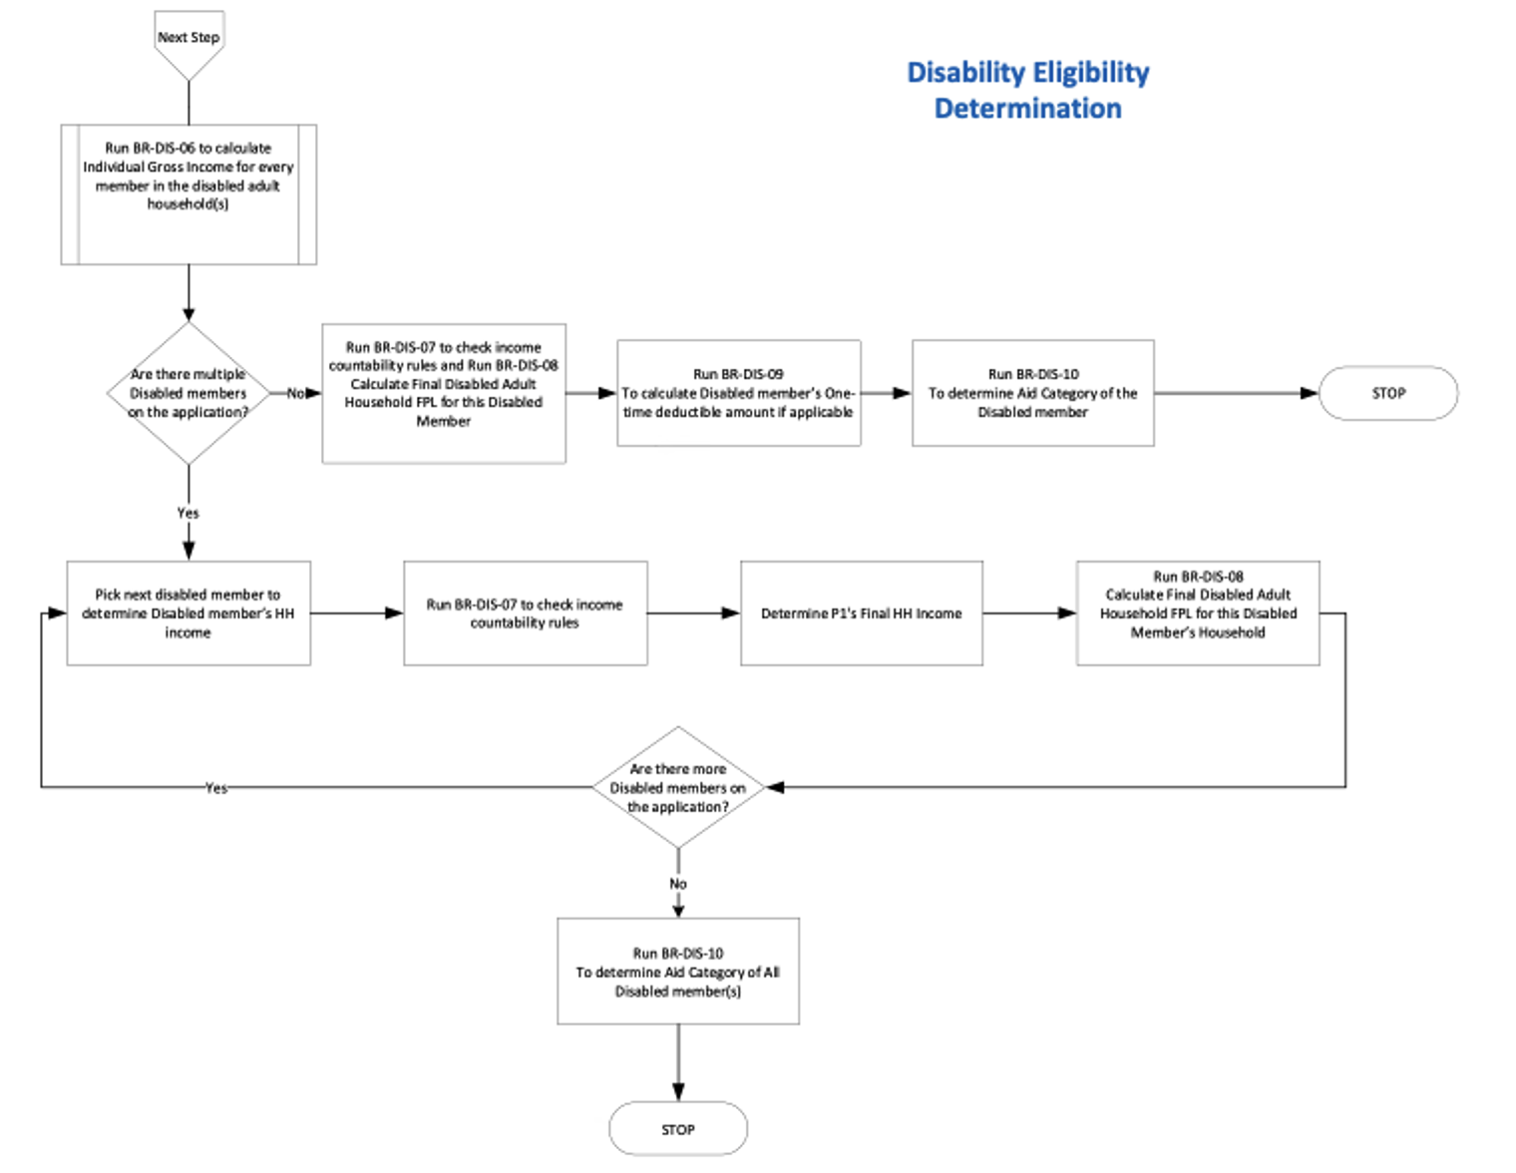

BR-DIS-01: Relationship Code Determination
This is to identify and map relationship code for each relative with respect to the disabled member.

Table 1: Input Parameters for (BR-DIS-01)
Parameter | Description | Possible values
Relationship_To_Member | Relationship with Member | Self  Spouse  Parent  Son/Daughter  Stepson/Stepdaughter  Grandchild  Sibling/stepsibling  Domestic Partner  Stepparent  uncle/aunt  nephew/niece  Grandparent  First Cousin  Parent's Domestic Partner  Brother-in-law/Sister-in-Law  Child of Parent’s Domestic Partner (Collateral Dependent)  Court Appointed Guardian  Daughter-in-law/Son-in-law  Former Spouse/Separated  Foster Child  Guardian  Mother-in-law/Father-in-law  Unrelated

Table 2: Output Parameters for (BR-DIS-01)
Parameter | Description | Possible values
Relationship_Code | Unique Code for each relation | 01 Self  02 Spouse  03 Parent  04 Child (Son/Daughter)  05 Stepchild (Stepson /Stepdaughter)  06 Grandchild  07 Sibling/stepsibling  08 Domestic Partner  12 Step-Parent  13 Uncle/aunt  14 nephew/niece  15 Grandparent  16 Cousin (First Cousin)  17 Parent's Domestic Partner  23 Sibling-in-law (Brother-in-law/Sister-in-Law)  24 Child of Parent’s Domestic Partner (Collateral Dependent)  25 Ward (Court Appointed Ward)  26 Child-in-law (Daughter-in-law/Son-in-law)  27 Former Spouse  28 Foster Child  29 Guardian  30 Parent-in-law (Mother-in-law/Father-in-law)  32 Unrelated  34 Foster Parent

Table 3: Processing Logic for (BR-DIS-01)
Relationship_To_Member | Relationship_Code
Self | 01
Spouse | 02
Parent | 03
Child (Son/Daughter) | 04
Stepchild (Stepson/Stepdaughter) | 05
Grandchild | 06
Sibling/stepsibling | 07
Domestic Partner | 08
Stepparent | 12
uncle/aunt | 13
nephew/niece | 14
Grandparent | 15
Cousin (First Cousin) | 16
Parent's Domestic Partner | 17
Sibling-in-law (Brother-in-law/Sister-in-Law) | 23
Child of Parent’s Domestic Partner (Collateral Dependent) | 24
Ward (Court Appointed Ward) | 25
Child-in-law (Daughter-in-law/Son-in-law) | 26
Former Spouse | 27
Foster Child | 28
Guardian | 29
Parent-In-law (Mother-in-law/Father-in-law) | 30
Unrelated | 32

BR-DIS-02: Disability Determination
This is to determine if the member is verified disabled or not.

Table 4: Input Parameters for (BR-DIS-02)
Parameter | Description | Possible values
Is Self-Attested Disabled | This is if member is attesting to being disabled | TRUE  FALSE
Is verified disabled | This is the response that we receive from SSA (FDSH/RRV) or Back Office via Agent Portal OR External state-based Interface | TRUE  FALSE

Table 5: Output Parameters for (BR-DIS-02)
Parameter | Description | Possible values
Is_Disabled | This is to determine whether the member is considered disabled or not | TRUE  FALSE

Table 6: Processing Logic for (BR-DIS-02)
P1  Is Self-Attested Disabled | P1  Is verified disabled? | P1  Is_Disabled
FALSE | FALSE | FALSE
FALSE | TRUE | TRUE
TRUE | FALSE | FALSE
TRUE | TRUE | TRUE

BR-DIS-03: Determining Disabled Adult Household Creation
This is used to determine if member meets the ‘Disabled’ criteria to create a household.

Table 7: Input Parameters for (BR-DIS-03)
Parameter | Description | Possible values
Is_Disabled | Output from BR-DIS-02 | TRUE  FALSE
Is_Adult | This is to indicate the age of the member  (≥ 19 < 65) | TRUE  FALSE
Is Medicare enrolled from Hub | This is to indicate if the member is enrolled in Medicare from HUB | TRUE  FALSE

Table 8: Output Parameters for (BR-DIS-03)
Parameter | Description | Possible values
Create Disabled Adult Household | This is to determine if a Disabled Adult HH should be created for the member | TRUE  FALSE

Table 9: Processing Logic for (BR-DIS-03)
P1  Is_Disabled | P1  Is_Adult | P1  Is Medicare enrolled from Hub | Create Disabled Adult Household
FALSE | TRUE | FALSE | FALSE
FALSE | TRUE | TRUE | TRUE
FALSE | FALSE | FALSE | FALSE
FALSE | FALSE | TRUE | FALSE
TRUE | TRUE | N/A | TRUE
TRUE | FALSE | N/A | FALSE

BR-DIS-04: Disabled Adult Household Generation
This is to determine who to add to the ‘Disability’ household and to determine the household size.

Table 10: Input Parameters for (BR-DIS-04)
Parameter | Description | Possible values
Create Disabled Adult Household for P1 | Output of BR-DIS-03 | TRUE  FALSE
Relationship to Member | Output of BR-DIS-01  (P2’s relationship with P1) | 01 – Self  02 - Spouse  03 - Parent  04 - Child (Son/Daughter)  05 - Stepchild (Stepson /Stepdaughter)  06 - Grandchild  07 - Sibling/stepsibling  08 - Domestic Partner  12 - Step-Parent  13 - Uncle/aunt  14 - nephew/niece  15 - Grandparent  16 - Cousin (First Cousin)  17 - Parent's Domestic Partner  23 - Sibling-in-law (Brother-in-law/Sister-in-Law)  24 - Child of Parent’s Domestic Partner (Collateral Dependent)  25 - Ward (Court Appointed Ward)  26 - Child-in-law (Daughter-in-law/Son-in-law)  27 - Former Spouse  28 - Foster Child  29 - Guardian  30 - Parent-in-law (Mother-in-law/Father-in-law)  32 - Unrelated  34 - Foster Parent
Does P2 live with P1 | If P1 and P2 live together | TRUE  FALSE

Lives with check:
Every time system checks if 2 members are Living together or not, we need to check if the other Member is alive or Not.
If other member is dead or incarcerated for Medicaid purposes then, Lives with flag cannot be set True. This is applicable throughout the document on “Lives with” condition.

Table 11: Output Parameters for (BR-DIS-04)
Parameter | Description | Possible values
Include in Disabled Adult Household | This indicates if the other member should be added to household  Add P2 to P1’s household | TRUE – Add  FALSE – Do not Add

Table 12: Processing Logic for (BR-DIS-04)
Create Disabled Adult Household for P1 | P2’s Relationship with P1 | P2 is <19 years of age | P1 and P2  Live Together? | Add P2 to P1’s Household
TRUE | 1 | N/A | N/A | TRUE
TRUE | 2 | N/A | TRUE | TRUE
TRUE | 2 | N/A | FALSE | FALSE
TRUE | 4/5 | Yes | TRUE | TRUE
TRUE | 4/5 | Yes | FALSE | FALSE
TRUE | 4/5 | No | N/A | FALSE
TRUE | Except 1/2/4/5 | N/A | N/A | FALSE
FALSE | N/A | N/A | N/A | FALSE

BR-DIS-05: Disabled Adult Household Size Calculation
This rule is to calculate number of Household Members in the Disabled Adult Household.

Table 13: Input Parameters for (BR-DIS-05)
Parameter | Description | Possible values
Household Members Count | Number of members in the Disabled Adult Household  Output from BR-DIS-04 | Number
Total_Babies_Due | Count of the children expected for the entire disability household | Number

Table 14: Output Parameters for (BR-DIS-05)
Parameter | Description | Possible values
DisabilityHouseholdSize | Count of members in Disabled Adult Household for P1 | Number

Table 15: Processing Logic for (BR-DIS-05)

Household Members Count | Total_Babies_Due | Calculation Formula (Disability HH Size)
Number | Number | Household Members Count + Total_Babies_Due

Total babies due includes the babies of the other pregnant members in the disabled adult household of the member for which household is created.

BR-DIS-06: Gross Income Calculation
This rule calculates income for the individual in the Disabled Adult household.

Income is captured both for the current time frame and the total year. For Disability income calculation, the system will be looking at the current time frame instead of total year.

Table 16: Input Parameters for (BR-DIS-06)
Parameter | Description | Possible values
Earned Income | - Job income  - Self-employment/s-Corporation/partnership income  - Farming and Fishing | Number
Unearned Income | - Social Security Benefits  - Unemployment  - Retirement or Pension  - Capital Gains  - Interest, Dividends, or Other Investment Income  - Rental or Royalty Income  - Alimony Received  - Lottery and Gambling Winnings  - Other Income | Number
Deductions | - Educator expense Information  - Certain business expenses of reservists, performing artists, or fee-based government officials Information  - Health Savings Account deduction Information  - Moving expenses related to a job change (for active duty service members only) Information  - Deductible part of self-employment tax Information  - Contribution to self-employed SEP, SIMPLE, and qualified plans Information  - Self-employed health insurance deduction Information  - Penalty on early withdrawal of savings Information  - Alimony paid Information  - Individual Retirement Account (IRA) deduction Information  - Student loan interest paid Information  - Higher education tuition and fees Information  - Domestic Production Activities Deduction Information  - Other | Number

Table 17: State Configuration Parameters Income Calculation Logic for (BR-DIS-06)
Income Source | Income Type | Include/Exclude in Final income calculation | Include/Exclude from Tax Threshold
job income | Earned Income | Include | Include
self-employment/s-Corporation/partnership income | Earned Income | Include | Include
Farming and Fishing | Earned Income | Include | Include
rental income | Unearned Income | Include | Include
unemployment income | Unearned Income | Include | Include
Retirement and pension income | Unearned Income | Include | Include
alimony income | Unearned Income | Include | Include
interest income | Unearned Income | Include | Include
capital gains income | Unearned Income | Include | Include
gambling income | Unearned Income | Include | Include
social security benefits (SSB) | Unearned Income | Include | Exclude
other income | Unearned Income | Include | Include
educator deduction | Deduction | Include | Include
reservist/performance artist/fee-based government official deduction | Deduction | Include | Include
health savings account deduction | Deduction | Include | Include
moving deduction | Deduction | Include | Include
self-employment tax deduction | Deduction | Include | Include
self-employment retirement plan deduction | Deduction | Include | Include
self-employment health insurance deduction | Deduction | Include | Include
penalty on early withdrawal deduction | Deduction | Include | Include
alimony paid to former spouse deduction | Deduction | Include | Include
IRA deduction | Deduction | Include | Include
student loan interest deduction | Deduction | Include | Include
tuition and fees deduction | Deduction | Include | Include
Domestic Production Activities deduction Information | Deduction | Include | Include
Other | Deduction | Include | Include

Note: The above table may be configured by state to indicate what type of income to account as household Income for disability.

Table 18: Output Parameters for (BR-DIS-06)
Parameter | Description | Possible values
Member’ Individual Gross Income | Individual’s calculated gross income | Number

Calculation Logic
Member’s Individual Gross Income for Disability = Individual’s total earned income + Individual’s total unearned income – Individual’s total deductions

BR-DIS-07: Income Countability Rule

This rule determines if the income of a particular member shall be counted towards income of household. This rule applies to Self-Attested/Manually verified/HUB income.

Generally, MAGI of all individuals in a Disabled Adult Household must be counted towards household income, but there are 2 exceptions for children and Tax Dependents.

Table 19: Input Parameters for (BR-DIS-07)
Parameter | Description | Possible values
Dependent Status | If this Individual is Dependent on the individual for which we are determining income inclusion? | TRUE  FALSE
Required to file Taxes | TRUE if  Unearned income > $1000 Per Year  or  Earned income > $6100 Per Year  Note: That these values are configurable and may change from year to year. | TRUE  FALSE
Claiming Tax Filer in same HH | If Dependent and Claimer’s Disabled Adult Household are same | TRUE  FALSE
In Parent’s HH | If Individual’s parent is in the Disabled Adult household for which we are determining income inclusion | TRUE  FALSE
Tax filer parent | If the individual’s tax filer is their parent | TRUE  FALSE
Tax filer spouse | If the individual’s tax filer is their spouse | TRUE  FALSE

Table 20: Output Parameters for (BR-DIS-07)
Parameter | Description | Possible values
Count Income | Flag to identify if we need to count this Individual’s income towards the disability household income or not | TRUE  FALSE

Table 21: Processing Logic for (BR-DIS-07)

Is P1 a member of the Household for which we are counting income | P1 Required to file Taxes | Is P1’s Parent in Household? | Count | Is P1 claimed as a dependent by this household member (for which we are counting)? | Is P1’s tax filer in the household? | Count Income?
TRUE | TRUE | N/A | TRUE | N/A | N/A | TRUE
TRUE | FALSE | FALSE | Continue | FALSE | FALSE | TRUE
 |  |  |  | FALSE | TRUE | FALSE
 |  |  |  | TRUE | N/A | FALSE
TRUE | FALSE | TRUE | FALSE | N/A | N/A | FALSE

Additional Rule to Count Member’s SSA Income in the household:

From above Table (Processing Logic for (BR-DIS-07)) system identifies the Member(s) whose income will be Included in the Disabled Adult Household. System runs additional rule on these Member(s) to Include/Exclude their SSA Income in the Disabled Adult Household only while calculating Self attested or manually verified income.
Below is the rule in detail:

Table 22: Processing Logic Income Rules

Does P1 have a SSA Income? | Is P1s Income Countable as per above Rule? | Is P1 a Medicaid Age Child? | Does P1 Live with their Parents? | Is P1 a Tax Dependent? | Is P1’s Income (Excluding SSA Income) > Threshold Limit? | Count SSA Income?
No | NA | NA | NA | NA | NA | No
Yes | No | NA | NA | NA | NA | No
Yes | Yes | Yes | No | NA | NA | Yes
Yes | Yes | Yes | Yes | NA | No | No
Yes | Yes | Yes | Yes | NA | Yes | Yes
Yes | Yes | NA | NA | Yes | No | No
Yes | Yes | NA | NA | Yes | Yes | Yes

Note: This is the same table that is used to evaluate MAGI income and FPL.
Disabled Adult Household income = Sum of MAGI of each member whose income is considered countable as per Table 21 and Table 22.

BR-DIS-08: Final Disabled Adult FPL Calculation
This rule calculates Disabled Adult Household FPL based on Disabled Adult Household income and size of household.

Table 23: Input Parameters for (BR-DIS-08)
Parameter | Description | Possible values
Disabled Adult HH Income | Disabled member’s household income determined from Income Calculation (BR-DIS-07) | Number
Disabled Adult HH Size | Household size as per BR-DIS-05 | Number

Table 24: Output Parameters for (BR-DIS-08)
Parameter | Description | Possible values
FPL | FPL Limit for eligibility | Number %

Calculation of household FPL is two-step process:
Step 1: Get 100% FPL from the table below using size of the household
Step 2: Calculate FPL as Household FPL = Household Income / 100%FPL

Note: 5% disregard will be applied.

Disabled Adult HH FPL% = (Disabled Adult HH Income/ FPL Limit of HH size) *100

Table 25: Processing Logic for (BR-DIS-08)
HH Size  (Persons in Household) | 100% FPL  (Monthly Income) based on Federal Poverty Guidelines - 2022
0 | 0
1 | $1,132.50
2 | $1,525.83
3 | $1,919.17
4 | $2,312.50
5 | $2,705.83
6 | $3,099.17
7 | $3,492.50
8 | $3,885.83
 | + $393 for each extra member

Example 1: Household with 3 members
- Number of members in the household is 3
- Household Income is $5000
- 100% FPL Poverty Guideline for 3 members is $1,919.17
- FPL% = (5000/1919.17) *100 = 260.53%

FPL% displayed on screen and used in downstream processes after incorporating 5% disregard = 255.53%

Example 2: Household with 8 members
- Number of members in the household is 8
- Household Income is $7000
- 100% FPL Poverty Guideline for 8 members is $3,866
- FPL% = (7000/3885.83) *100 = 180.14%

FPL% displayed on screen and used in downstream processes after incorporating 5% disregard = 175.14%

System shall subtract the 5% FPL disregard. The behavior of applying 5% disregard for Disabled Adult HH FPL and MAGI FPL will be identical.

Note: The above table is configurable in the system.

BR-DIS-10: Aid Category Determination
The aid category of the member will be assigned after the program determination. The details of the aid categories have been documented in the ‘Disability Eligibility Enhancements’ PRSD.

